

**Diploma Engineering**



**Semester V**



**CE, IT, AIML, Cloud Computing &**



**Big Data, Gaming & Animation**

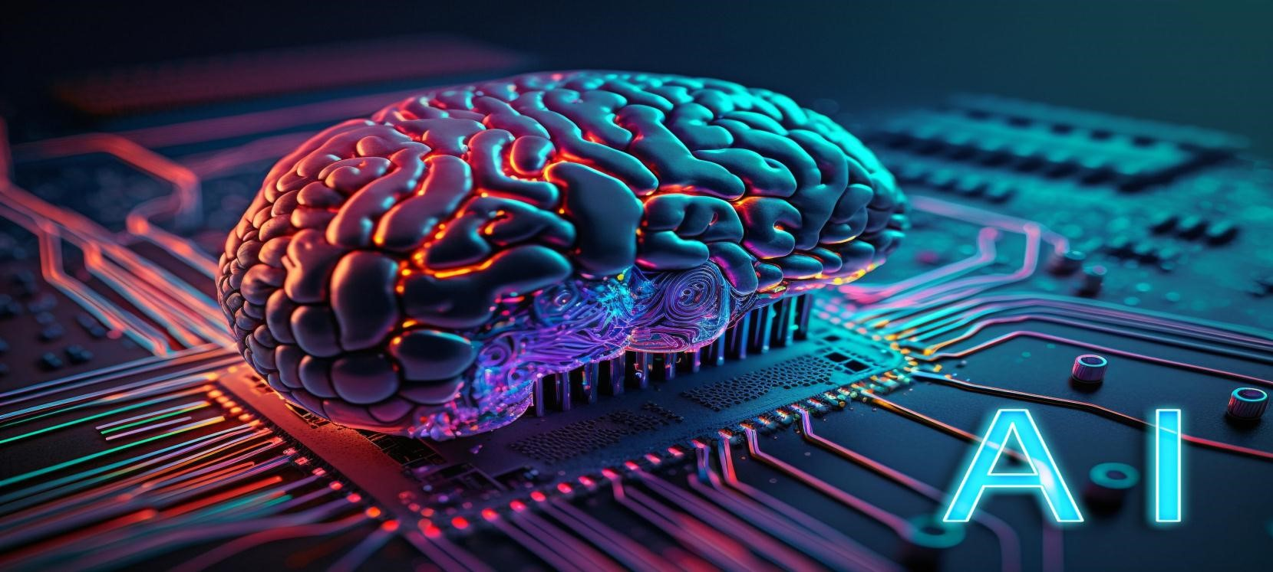

# An Overview of Major Computer & Technology Disciplines

***Computer Engineering*** is a branch of engineering that integrates several fields of computer science and electronic engineering required to develop computer hardware and software. Computer engineers design, test, implement and maintain computer software and hardware systems.

***Information Technology (IT)*** is the use of computers to store or retrieve data and information. IT is typically used within the context of business operations as opposed to personal or entertainment technologies. You can find IT specialization in every branch of education, from IT & Software, Engineering, Aviation and Medicine to MBA and even Hospitality.

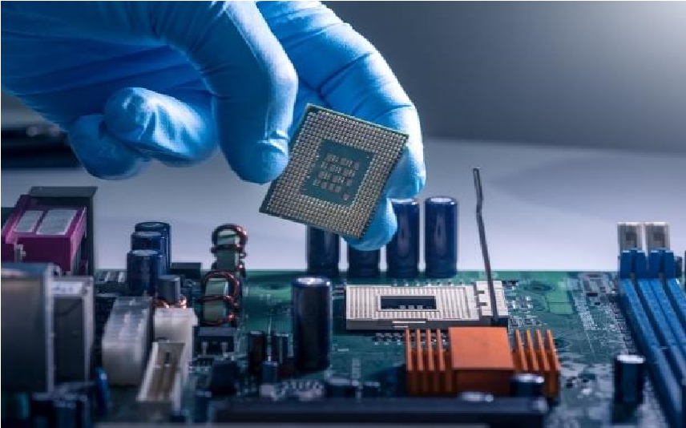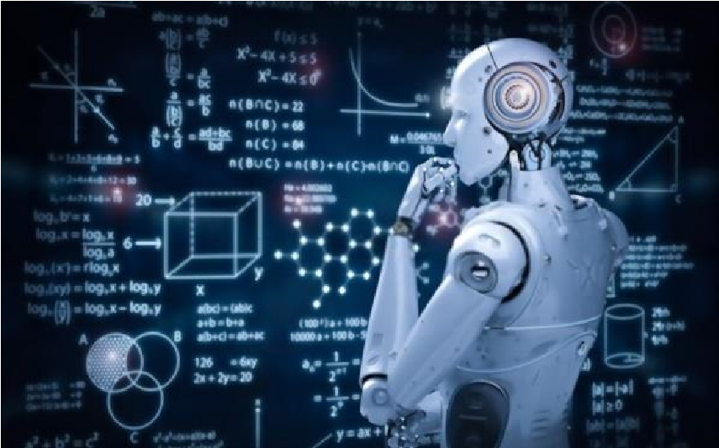

***Artificial Intelligence (AI)*** is intelligence demonstrated by machines, as opposed to the natural intelligence displayed by humans or animals. AI applications include advanced web search engines, recommendation systems used by YouTube, Amazon and Netflix, Siri or Alexa, Tesla, and strategic game systems (such as chess and Go).

***Cloud Computing & Big Data*** is the on-demand availability of computer system resources, especially data storage (cloud storage) and computing power, without direct active management by the user.Big data is a field that treats ways to analyze, systematically extract information from, or otherwise, deal with data sets that are too large or complex to be dealt with by traditional data-processing application software.

***Gaming & Animation*** is the process of developing/designing a game. The effort is undertaken by a developer, ranging from a single person to an international team dispersed across the globe.Animation is a method in which figures are manipulated to appear as moving images. Various tools available in the market today, ease out the tasks of game development and animation.

# Disclaimer

This handbook is compiled to provide subject information to the students. Every effort has been made to avoid errors & omissions and ensure accuracy. Any error noted may be brought to the notice of the compiler, which shall be taken care of in the updated edition of this handbook. The sources of information/material are provided in the appendix.

The information contained in this handbook is strictly for education and learning purposes and not for any commercial use.

Furthermore, The University reserves the right to unilaterally and without notice make changes to this handbook at any time.



**Evaluation Methodology**

**Theory Marks**

## PA: Progressive Assessment

Units’ examinations will be conducted during the semester. Each unit examination is compulsory. Unit examination may be taken from objectives, short questions, long questions, etc.

Unit-1 Exam: Maximum Marks 10

Unit-2 Exam: Maximum Marks 10

Unit-3 Exam: Maximum Marks 10

Unit-4 Exam: Maximum Marks 10

**Total Marks 40**

## ESE: End Semester Exam

End semester examination will be conducted from all Five (5) units and it is compulsory. It may be taken in the form of objectives, short questions, long questions etc.

End Semester Exam: Maximum Marks 50

## CA: Continuous Assessment

Continuous assessment will be evaluated from the activity assigned in the semester and the attendance of that particular subject.

Activity Assessment / Attendance: Maximum Marks 10

**Practical Marks**

## PV: Practical Viva

Practical viva will be conducted through group task. Thereafter viva will be conducted individually based on the given task of the concerned subject.

Practical Viva: Maximum Marks 30

## TW: Term Work

Term work will be considered from the assignment and laboratory work done by the student during the semester of that particular subject.

Term Work: Maximum Marks 20

**EVALUATION SCHEME**

The performance of students is evaluated on the basis of continuous and semester-end examinations with letter grades O+++, O++, A++, B, etc. Which have numerical equivalents called grade points as indicated below:

**Percentage Grade Point Grade Class**

**95 100 10 O+++**

**90 94 9.5 O++**

**85 89 9 O+ First Class with**

**80 84 8.5 O Distinction**

**75 79 8 A++**

**70 74 7.5 A+**

**65 69 7 A**

**First Class**

**60 64 6.5 B++**

**55 59 6 B+ Higher Second Class**

**50 54 5.5 B**

**45 49 5 C Second Class**

**40 44 4.5 D**

**35 39 4.0 E Pass Class less than 35 0 F Fail**

The performance of a student in a semester is indicated by a number called SPI (Semester Performance Index). The SPI is the weighted average of the grade points obtained in all the subjects taken by the student during the semester. Example: Suppose in a given semester a student has taken subjects having credits C1, C2, C3, C4, C5..... And the numerical equivalent of grades obtained in those subjects are G1, G2, G3, G4, and G5 respectively.

SPI = Grade Points Earned ∑𝑛𝑖=1 𝐶𝑖 𝐺𝑖

Then his/her Total Offered Credits = ∑𝑛𝑖=1 𝐶𝑖

SPI will be calculated (after re-examination, if any) up to two decimal places on the basis of the final grades.

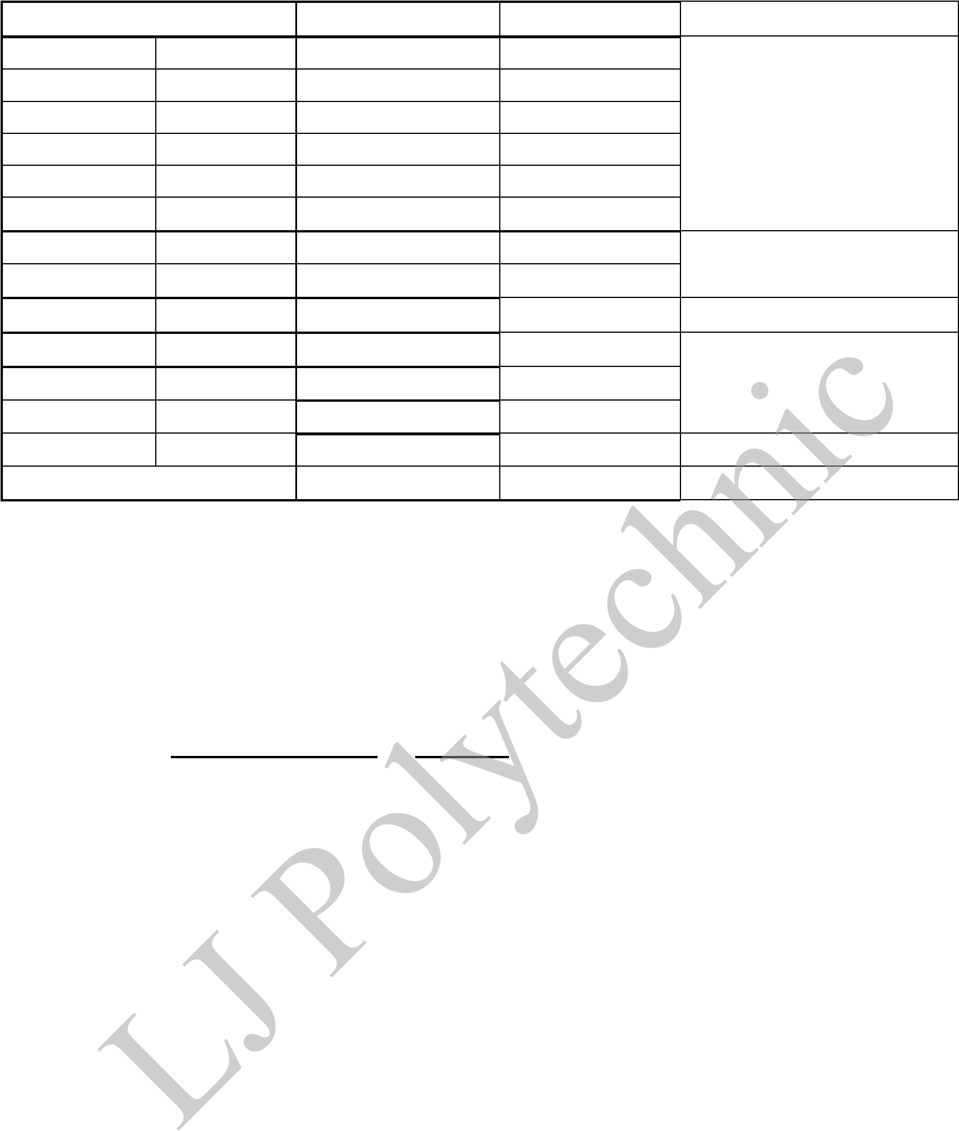An overall assessment from the time the student entered the course is obtained by calculating PPI (Progressive Performance Index). The PPI is the weighted average of the grade points obtained in all the subjects taken by the student since he/she entered the course. It is calculated in the same manner as the SPI. The CGPA (Cumulative Grade Points Average) is the weighted average of the grade points obtained in all the subjects in the last six semesters of the course.

**Detention:**

**Formula for conversion of equivalent percentage of PPI**

An equation to find equivalence between PPI or CGPA may be obtained as follows:

Percentage Marks = (PPI or CGPA — 0.5) x 10. SPI or PPI or CGPA equivalent class shall be as follows:

Below 4.00 : Fail

4.00 – 4.49 : Pass Class

4.50 – 5.50 : Second Class

5.51 – 6.00 : Higher Second Class

6.01 – 7.49 : Firsrt Class

7.50 and above : First Class with Distinction

For all courses, where the duration of the course is more than 2 years, the degree shall be awarded to the students on the basis of CGPA of the last six semester's performance in the exams.

In case of the courses where duration is of two years, the degree shall be awarded to students based on PPI considering the performance in all four semesters.

## About Bloom’s Taxonomy

Bloom’s Taxonomy is a classification of the different objectives and skills that educators set for their students (learning objectives). The taxonomy was proposed in 1956 by Benjamin Bloom, an educational psychologist at the University of Chicago. The terminology has been recently updated to include the following six levels of learning. These 6 levels can be used to structure the learning objectives, lessons, and assessments of your course.

1. **Remembering:** Retrieving, recognizing, and recalling relevant knowledge from long‐term memory.
2. **Understanding:** Constructing meaning from oral, written, and graphic messages through interpreting, exemplifying, classifying, summarizing, inferring, comparing, and explaining.
3. **Applying:** Carrying out or using a procedure for executing, or implementing.
4. **Analyzing:** Breaking material into constituent parts, determining how the parts relate to one another and to an overall structure or purpose through differentiating, organizing, and attributing.
5. **Evaluating:** Making judgments based on criteria and standards through checking and critiquing.
6. **Creating:** Putting elements together to form a coherent or functional whole; reorganizing elements into a new pattern or structure through generating, planning, or producing.

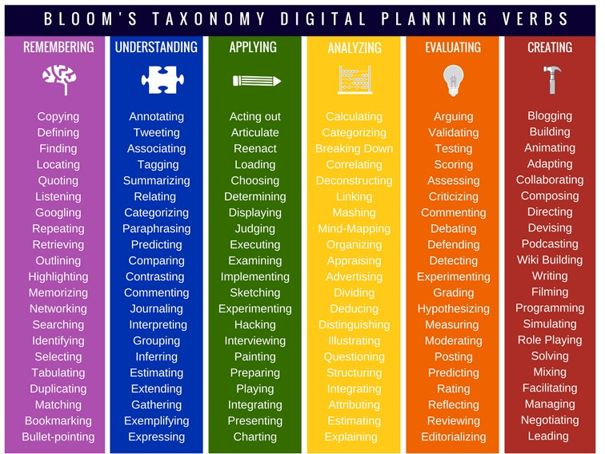



# FUNDAMENTALS OF AI



**Prepared and Compiled by**

**CE & IT Department**

## Course

|  |  |  |  |  |  |  |
| --- | --- | --- | --- | --- | --- | --- |
| **Course Title** | Fundamentals of AI | |  |  |  |  |
| **Course Type** | HSSC | BSC | ESC | PCC | OEC | PEC |

**Legends:** HSSC: Humanities and Social Sciences Courses

BSC: Basic Science Courses

ESC: Engineering Science Courses

PCC: Program Core Courses

OEC: Open Elective Courses

PEC: Program Elective Courses

## Teaching and Evaluation Scheme

|  |  |  |  |  |  |  |  |  |  |  |  |
| --- | --- | --- | --- | --- | --- | --- | --- | --- | --- | --- | --- |
| **Teaching Hours / Week** | | | | **Evaluation Scheme** | | | | | | |  |
| **Theory Marks** | | | | **Practical Marks** | | | **Total**  **Marks** |
| **L** | **T** | **P** | **Total Credit** | **ESE** | **CA** | **PA** | **Total** | **PV** | **TW** | **Total** |
| 3 | - | 4 | 5 | 50 | 10 | 40 | 100 | 30 | 20 | 50 | 150 |

|  |  |
| --- | --- |
| **Legends:** | ESE: End Semester Exam |
|  | CA: Continuous Assessment (Attendance + Activity) |
|  | PA: Progressive Assessment |
|  | PV: Practical Viva |
|  | TW: Term Work |
|  |  |

## Contents

|  |  |  |  |  |  |  |
| --- | --- | --- | --- | --- | --- | --- |
| **Unit No.** | **Topics** | **Sub-Topics** |  | **Learning Outcomes** | **%**  **Weightage** | **Hours** |
| **1** | **Introduction to AI** | 1.1.Introduction  1.2.Applications and History Of AI  1.3.The AI Risks and Benefits  1.4.Agents And  Environments  1.5.Problems, Problem  Spaces  1.6.Production  Systems,  Production  Characteristics  1.7.Knowledge Representation  1.8.Propositional Logic, Predicate  Logic  1.9.Reasoning | •  • | Understand  what is  Artificial  Intelligence  Understand and use different types of knowledge and logic representation schemes | 30 | 12 |
| **2** | **Search**  **Techniques** | 2.1.Issues in The Design of Search Programs  2.2.Uniformed Search Techniques (BestFirst Search,  Depth-First  Search)  2.3.Heuristic Search Techniques  (Generate-And-  Test, Hill Climbing, A*  Algorithm)  2.4.Adversarial Search Techniques (Game  Playing,  MINIMAX  Algorithm) | •  • | Understand the  search technique procedures applied to real world problems  Understand Game Playing technique and apply to  programs | 20 | 7 |
| **3** | **Inference Techniques** | 3.1.Propositional Logic  3.2.First-Order Logic 3.3.Representing Knowledge Using Rules  3.4.Procedure Versus  Declarative  Knowledge  3.5.Forward Versus  Backward  Reasoning | •  • | Understand various inference techniques Understand various logic types and how to apply them | 20 | 9 |
| **4** | **Libraries and Datasets** | 4.1.Jupyter  Installation and  Use  4.2.Datasets: Kaggle 4.3.Python Libraries: Numpy, Pandas,  Matplotlib. | •  •  • | Learn to install  Jupyter  notebook and  how to use it  Understand the basics of datasets and  libraries  required for  Machine  Learning | 15 | 6 |
| **5** | **Data Analysis and Processing** | 5.1.Introduction to Data Analysis And Visualization  5.2.Types of Data (Numerical,  Categorical, Text)  5.3.Introduction to  Data  Preprocessing  5.4.Handling Missing Values  5.5.Handling Outliers and  Inconsistencies | •  •  • | To understand of types of data To learn about structure and quality of data An understanding  about data preprocessing  and its  techniques | 15 | 8 |

**Total**

**42**

**Hours**

## Suggested Specification Table with Hours

|  |  |  |  |  |  |  |  |  |
| --- | --- | --- | --- | --- | --- | --- | --- | --- |
| **Unit No.** | **Chapter Name** | **Teaching Hours** | **Distribution of Topics**  **According to Bloom’s Taxonomy** | | | | | |
| **R**  **%** | **U**  **%** | **App %** | **C**  **%** | **E**  **%** | **An %** |
| 1 | Introduction to AI | 12 | 40 | 30 | 20 | - | 5 | 5 |
| 2 | Searching Techniques | 7 | 30 | 30 | 20 | - | 10 | 10 |
| 3 | Inference Techniques | 9 | 20 | 30 | 30 | - | 10 | 10 |
| 4 | Libraries and Datasets | 6 | 20 | 20 | 20 | 10 | 15 | 15 |
| 5 | Data Analysis and Processing | 8 | 20 | 20 | 30 | 10 | 10 | 10 |

**Legends:** R: Remembering U: Understanding

App: Applying C: Creating E: Evaluating An: Analyzing

### Textbooks

1. “Artificial Intelligence: A Modern Approach”, Stuart Russel, Peter Norvig, PHI-Latest Edition.
2. “Python for Data Analysis”, Wes McKinney, O'Reilly Media-Latest Edition.

### Reference Books

1. “Artificial Intelligence: A new Synthesis”, Nilsson. J. Nils, Harcourt Asia Pvt. Ltd.Latest Edition.
2. “Artificial Intelligence”, Elaine Rich and Kevin Knight (2nd Edition), Tata McGrawHill-Latest Edition.

### Open Sources (Website, Video, Movie)

1. <https://nptel.ac.in/courses/106/105/106105077/>
2. http://www.journals.elsevier.com/artificial-intelligence/
3. <https://www.nltk.org/#natural-language-toolkit>
4. https://pandas.pydata.org
5. https://numpy.org

## Introduction

With the use of internet and World Wide Web increasing day by day, the field of AI and its techniques are being applied in many areas that directly affect human life. Various techniques for encoding Knowledge in computer systems such as predicate logic, production rules, and semantic networks find Applications in real world problems. Areas of AI such as Game Playing, Natural Language Processing, and Connectionist Models are also important. Student should know some programming language for AI.

## Objectives

* The theory should be taught and practical should be carried out in such a manner that students are Able to acquire different learning out comes in cognitive, psychomotor and affective domain to Demonstrate following course outcomes.
* To review and strengthen important mathematical concepts required for AI & ML.
* Introduce the concept of learning patterns from data and develop a strong theoretical foundation for understanding state of the art Machine Learning algorithms.

## Subject’s Learning Outcomes

This Course is aimed to make students be able to understand the How Artificial Intelligence is connected to real world. Also Students acquire knowledge of various approaches of problem solving and base information about Artificial Intelligence. They will be able to create programs using heuristics for problem solving.

Introduction to

AI

**Unit**

**-**

**1**



**Introduction to AI**

**1**



**Practical List**



1. Write a program to implement Tic-Tac-Toe game problem.
2. Write a program to solve Missionaries and Cannibals problem.
3. Write a program to solve Tower of Hanoi problem.



**Short Questions**

### Q. Bloom’s

**Sample Questions**

**No. Taxonomy**

1. What is AI? Remember
2. What is learning? Remember
3. Define the expert system. Remember
4. Define knowledge engineering. Analyzing

6. What is production systems? Remember

1. What is an Agent? Understand
2. Define reasoning. Evaluating
3. What is propositional logic? Remember
4. What is knowledge representation in AI? Remember
5. What are the different types of knowledge representation? Remember
6. What is a knowledge base in AI? Understand
7. What is predicate logic? Evaluating
8. What is frame-based representation? Understand
9. What is rule-based representation? Understand 18 What is knowledge acquisition in AI? Understand

Fundamentals of AI



**Long**

**Questions**

### Q. Bloom’s

**Sample Questions**

**No. Taxonomy**

1. Define intelligence. What is the intelligent behavior of a Remember machine?
2. What are the limitations of expert system? Remember
3. Explain AI techniques. Understand
4. Explain knowledge-based Agents. Remember
5. Explain PEAS with example. Creating
6. Explain inference rule. Apply
7. Explain declarative knowledge with Example. Remember 8. Explain reasoning in terms of AI. Understand



**Essential Assignments**

1. Define AI problems. Explain assumption of AI.
2. List out various AI technique and any two explain in detail.
3. Explain term 1) Agent 2) environment 3) state 4) action 5) reward.
4. What do you mean about representation and mappings?
5. Explain Various Approaches to knowledge representation.
6. Write a difference between procedural knowledge and declarative knowledge
7. Write a PEAS for advanced driver-assistance system.



**Desirable Assignments**

1. Explain Real world problems in AI.
2. Explain various types of knowledge.
3. Explain relation between knowledge and intelligence.
4. Explain logical connectives.
5. Explain 7 problems characteristics.
6. Explain first order logic?
7. Write a PEAS for auto vacuum cleaner system.

|  |
| --- |
| **Unit-1** |

Introduction to AI



**Activities**

1. Collect data for real time AI work in the World.
2. Write a program solve any real world problems in AI.
3. Write a PEAS for recycle waste robot.



**Learning**

**Outcomes**

* Knowledge about Artificial intelligence and learning will be gained.
* Knowledge about expert system and knowledge engineering will be acquired.
* Knowledge of production systems & AI Various component will be gained.
* Knowledge about representations and mappings will be gained.
* Knowledge about various knowledge representation approaches will be gained.
* Knowledge about procedural and declarative knowledge will be acquired.

Search Techniques

**Unit**

**-**

**2**



**Search Techniques**

**1**



**Practical List**



1. Write a program to implement BFS (Water Jug problem or any AI search problem).
2. Write a program to implement DFS (for 8 puzzle problem or Water Jug problem or any AI search problem).
3. Write a program for Hill climbing problem.
4. Write a program to implement A* algorithm.
5. Write a program to implement Single layer game (Using Heuristic function).



**Short Questions**

**Q. Bloom’s**

**Sample Questions**

**No. Taxonomy**

1. What is a search algorithm? Remember
2. Define 1) search space 2) search strategy. Remember
3. What are some example of uniformed search techniques? Understand

Why do heuristic search technique differ from uniformed search

1. Understand techniques?
2. What is DFS? Remember
3. What is BFS? Remember
4. Define Hill climbing problem. Understand
5. How does DFS explorer the search space? Apply
6. How does BFS determine which node to explore next? Apply
7. How does generate and test work? Apply
8. What main limitation of generate and test? Remember
9. How does the A* algorithm work? Apply



**Long**

**Questions**

**Q. Bloom’s**

**Sample Questions**

**No. Taxonomy**

1. What are the challenges of designing search algorithms that can Remember handle complex and uncertain environments and what are some strategies for addressing these challenges?

Fundamentals of AI

1. What are the different types of uniformed search algorithms used Understand in AI, and what are the key differences between them?
2. Explain A* algorithm in detail. Apply
3. Explain Hill climbing problem in detail. Remember
4. Explain MINIMAX algorithm in detail Apply



**Essential Assignments**

1. What are the different types of search algorithm used in AI, and what are the key differences between them?
2. Implement DFS and BFS for given value, and also generate tree.

[12,45,65,98,45,23,46,56,85,74,41,50,33,20,15,18]

1. Explain any one Heuristic search techniques in detail.
2. Explain any one Adversarial search techniques in detail
3. State space representation 8 puzzle



**Desirable Assignments**

1. What are some of the ethical implications of using search algorithms to automate decision-making in areas likes finance, law and medicine?
2. Write an algorithm steps on BFS and DFS.
3. What are some of the current trends and directions in the field of heuristic search algorithms, and what new challenges are emerging as AI system become more complex and sophisticated?
4. How does the A* algorithm work, and how does it differ from other heuristic search algorithm.

5 How do adversarial search algorithms differ when applied to different types of games, such as chess, Go and poker?



**Activities**

1. Implement the MINIMAX algorithm with alpha-beta pruning to create an AI players for a two-player game, such as tic-tac-toe or chess
2. Implement a hybrid search algorithm that combines multiple techniques, such as BFS with A* and beam search, to solve a complex problem.



**Learning Outcomes**

* Knowledge about various game playing techniques and apply them to programs will be gained.
* Knowledge about search technique and algorithms will be acquired.
* Understanding of search technique processes used to solve real-world situations will be learned.

Inference Techniques

**Unit**

**-**

**3**



**Inference Techniques**

**1**



**Practical List**



1. Write a program to solve N-Queens problem.
2. Write a program to solve 8 puzzle problem.
3. Write a program to solve travelling salesman problem.



**Short Questions**

**Q. Bloom’s**

**Sample Questions**

**No. Taxonomy**

1. Define non-monotonic reasoning Understand
2. What is default reasoning? Understand
3. Define inference rule? Remember
4. Define inheritance terms of non-monotonic reasoning? Remember
5. What is minimalist reasoning? Remember
6. What is LTMS? Understand
7. What is statistical reasoning? Apply
8. Define probability distribution with example. Apply
9. Write a characteristics of expert systems. Remember
10. What is forward chaining technique? Understand



**Long**

**Questions**

**Q. Bloom’s**

**Sample Questions**

**No. Taxonomy**

1. What are the basic components of propositional logic? Understand
2. What is first-order logic and how is it used in AI Apply
3. How do you represent rules in a knowledge base? Apply
4. How is procedural knowledge represented in AI system? Apply
5. How is declarative knowledge represented in AI system? Apply
6. Explain forward and backward reasoning? Remember

Fundamentals of AI



**Essential Assignments**

1. Explain non-monotonic reasoning and logics for non-monotonic reasoning?
2. What is the difference between propositional logic and predicate logic?
3. What are the advantages and limitations of using propositional logic in AI?
4. What are some common logical connectives used in first-order-logic?
5. What is the role of first-order logic in automated reasoning and decision making?
6. What are rules and how are they used to represent knowledge in AI?
7. What is the different types of rules used in AI?
8. What is the difference between procedural and declarative knowledge in AI?
9. What is the difference between Forward and backward reasoning in AI?



**Desirable Assignments**

1. Can propositional logic be used to represent uncertainty and vagueness in AI?
2. What are some common logical operators used in propositional logic?
3. How do you construct first-order logic statements and predicates?
4. What some real-world applications of rule-based system in AI?
5. How do you evaluate the effectiveness of procedural versus declarative knowledge in AI System?
6. What are some real-world application of backward and forward reasoning in AI?



**Activities**

1. Predicate logic representation knowledge apply on given sentence.
   1. Marcus was a man.
   2. Marcus was a Pompeian.
   3. All Pompeian’s were Romans.
   4. Caesar was a ruler.
   5. All Romans were either loyal to Caesar or hated Him.
   6. Everyone is loyal to someone.
   7. People only try to assassinate rulers they are not loyal to.
   8. Marcus tried to assassinate Caesar.
2. Answer the Question “Did Marcus hate Caesar?”
   1. Marcus was a man.
   2. Marcus was a Pompeian.
   3. All Pompeian’s were Romans.
   4. Caesar was a ruler.
   5. All Romans were either loyal to Caesar or hated Him.
   6. Everyone is loyal to someone.
   7. People only try to assassinate rulers they are not loyal to.
   8. Marcus tried to assassinate Caesar.

Inference Techniques **Unit-3**



**Learning Outcomes**

* Knowledge about non-monotonic reasoning will be gained.
* Knowledge about propositional logic and predicate logic will be acquired.
* Knowledge about first-order logic and its application will be acquired.
* Knowledge about rule-based system will be gained.
* Knowledge about procedural and declarative knowledge will be acquired.
* Knowledge about backward and forward reasoning will be gained.

Libraries and Datasets

**Unit**

**-**

**4**



**Libraries and Datasets**

**1**



**Practical List**



* 1. Explore the numpy, pandas library and implement various operations:
     + Data processing using various statistical technique (numpy library).
     + Making a data using Data frame and apply statistical technique (Pandas library).
  2. Explore the matplotlib library and implement various visualization based operations.
     + Bar plot
     + Scatter plot
     + Pie plot



**Short Questions**

### Q. Bloom’s

**Sample Questions**

**No. Taxonomy**

1. What is jupyter notebook? Remember
2. What are the main features of jupyter notebook? Remember
3. How can you create a new notebook in jupyter? Apply

What are the different types of outputs supported by jupyter

1. Remember

Notebook?

1. What is dataset? Understand
2. Define python library. Remember
3. What is numpy? Remember
4. What is pandas? Remember
5. What is matplotlib? Remember



**Long**

**Questions**

|  |  |  |
| --- | --- | --- |
| **Q.**  **No.** | **Sample Questions** | **Bloom’s Taxonomy** |
| 1. | Write a steps of jupyter notebook installation? | Remember |
| 2. | Why we use dataset and how to create it? | Create |
| 3. | What is kaggle and what do work? | Understand |
| 4. | Explain python library in detail. | Remember |

Fundamentals of AI



**Essential Assignments**

1. Why we use jupyter notebook?
2. What is advantage and disadvantage of jupyter notebook?
3. What Anaconda distribution?
4. Write a characteristic of good dataset preparation?
5. Explain statistical function in term of numpy.
6. What is data-frame how to create data-frame using pandas library?
7. What is graph explain in detail?



**Desirable Assignments**

1. List another python library use for data visualization.
2. What is seaborn & how to differ the matplotlib library?
3. How to quality measure in dataset?
4. What is data analysis and how to work?



**Activities**

1. Perform all preprocessing task on a given dataset and transform it into clean data

* Detect outlier and remove it.
* Remove duplicate and handling missing values.
* Apply data reduction technique.
* Apply data transformation technique. • Plotting data.



**Learning Outcomes**

* Knowledge about jupyter notebook will be gained.
* Knowledge about dataset will be acquired.
* Knowledge about python libraries will be acquired.
* Knowledge about preprocessing technique will be gained.

Data Analysis and Processing

**Unit**

**-**

**5**



**Data Analysis and**

**Processing**

**1**



**Practical List**



1. Choose any one dataset from kaggle and implement Pre-processing task.
   * data profiling
   * data cleansing
   * data reduction
   * data transformation
   * data enrichment
   * data validation
2. Implement data pre-processing and data visualization on built-in dataset from scikitlearn and implement simple Machine Learning algorithm.



**Short Questions**

### Q. Bloom’s

**Sample Questions**

**No. Taxonomy**

1. What is data pre-processing? Remember
2. What is data visualization? Remember
3. What is outlier? Understand
4. What is missing values? Remember
5. Define inconsistencies. Understand
6. What is data abstraction? Understand
7. What is feature in data? Understand
8. What is feature engineering? Remember



**Long**

**Questions**

### Q. Bloom’s

**Sample Questions**

**No. Taxonomy**

1. Explain data cleaning technique. Apply
2. Explain feature engineering in term of data. Analyzing

Fundamentals of AI

1. Explain why we use ANN? Apply
2. Explain data visualization in details. Apply
3. What is machine learning how to use machine learning Apply algorithm?



**Essential Assignments**

1. Why we use preprocessing technique?
2. Explain all task of preprocessing technique.
3. Why we apply feature engineering?
4. What is model and how to evaluate model?
5. Explain term: 1) over-fitting 2) under-fitting 3) bias 4) variance 5) co-variance.
6. Explain EDA in detail.
7. Explain ANN?



**Desirable Assignments**

1. Write a function name we use in preprocessing technique?
2. Write a difference between preprocessing and feature engineering.
3. Write a difference between ANN and BNN?
4. List out machine learning algorithm and also when we use algorithms?



**Activities**

1. Implement data pre-processing and data visualization on Stock-market price dataset and implement Machine Learning algorithm.

* Implement various preprocessing technique.
* Implement feature engineering on data.
* Apply machine learning algorithm.



**Learning Outcomes**

* Knowledge about data preprocessing will be gained.
* Knowledge about feature engineering and model evaluating will be acquired.
* Knowledge about machine learning algorithm and artificial neural network will be acquired.

## Quotes from Pioneers

*“The advance of technology is based on making it fit in so that you do not really even notice it, so it is part of everyday life.”* ***- Bill Gates, Co-Founder, Microsoft.***



*“Have the courage to follow your heart and intuition. They somehow already know what you truly want to become. Everything else is secondary.”* ***- Steve Jobs, Co-Founder, Apple Inc.***

*“Success breeds complacency. Complacency breeds failure. Only the paranoid survives.”*



* ***Andy Grove, Former Chairman & CEO, Intel.***

*“If you are changing the world, you are working on important things. You’re excited to get up in the morning.”* ***- Larry Page,******Co-Founder, Google & Alphabet Inc.***

*“Progress is often equal to the difference between mind and mindset.”*

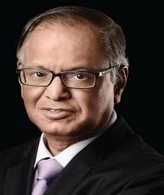

* ***N. R. Narayana Murthy, Chairman Emeritus, Infosys.***

*“The only way to learn new programming language is by writing programs in it.”*

* ***Dennis Ritchie, Co-Creator of C Programming.***

*“Success is achieved twice. Once in the mind and the second time in the real world.”*

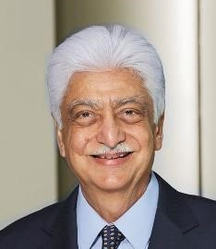

* ***Azim Premji,******Founder Chairman, Wipro.***

*“The digital world has power because it has dynamic information, but it's important that we stay human instead of being another machine sitting in front of a machine.”* ***- Pranav Mistry, President & CEO of STAR Labs.***

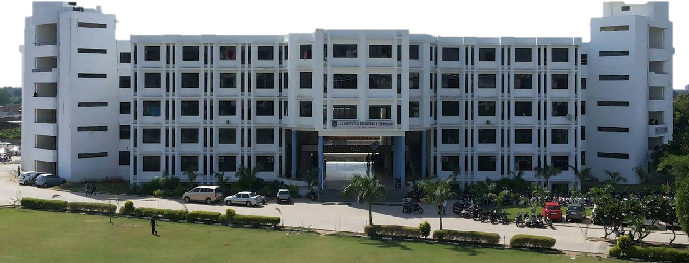

**LJ Polytechnic**



❖

**Automobile Engineering**

❖

**Mechanical Engineering**

❖

**Information Technology**

❖

**Computer Engineering**

❖

**Electrical Engineering**

❖

**Civil Engineering**

**Offers Diploma in**



**info_poly@ljku.edu.in**

**www.ljku.edu.in**

**9687010057**

**9228010057**



❖

**Artificial Intelligence & Machine Learning**

❖

**Electronics & Communication Engineering**

❖

**Cloud Computing & Big Data**

❖

**Architectural Assistantship**

❖

**Automation & Robotics**

❖

**Gaming & Animation**

**LJ Campus,**

**Near**

**Sarkhej**

**-**

**Sanand**

**Circle, Off. S. G. Road, Ahmedabad, Gujarat**

**-**

**382210**